# N.V. Society’s,

# N.V. Arts, Sri Kanhayalal Malu Science &

Dr.Pandurangrao Patki College of Commerce ,

Kalaburagi 585103 – Karnataka



**MENTOR – MENTEE**

**POLICY**

2018-19

Students Mentorship Policy

Students Mentorship is a activity which is initiated by IQAC of our college, which was an initiative by UGC, which enables college to bridge the gap between students and staff with a vision to extend support and guidance to the students studying in the college for the betterment of their academic and professional career and thereby contribute towards nation building. It is very effective system that is aimed to narrow down the gap between the mentee and the mentor and thereby the society in general. The students may come across difficulties during the degree programmes and have to face academic and adjustment challenges. To cope up with such problems and to enable them to excel in academics and profession as per their potential, a Mentor- Mentee programme for the students of the institution has been developed.

We are providing counseling to the students through personal attention and regular dialogues during their stay on campus, on telephone and by paying personal visits to the houses of the mentees allotted to the teacher concerned as the Mentor. We have been providing them tips on studies personal counseling, guidance regarding career choices, to get success in the university examinations. We have also been supporting the mentees in the form of precise content on courses, fees, reviews, college admission process and scholarships etc. The scheme has become very successful in bridging the gap between the teacher and the student. It has become instrumental in blending the harmonious relationship between the learner and his/her family and the institution at large. It has definitely created an atmosphere of conviction and faith about the alma mater. We aim that all students get rightly educated and take the right step towards building their career.

Largely Mentorship build bridges among stakeholders as follows:

* Principal & Stakeholders
* Students & Teachers
* Teachers& Parents
* Teachers & other related Committees& Counsellors

**Line of Reporting:**pal

Mentor

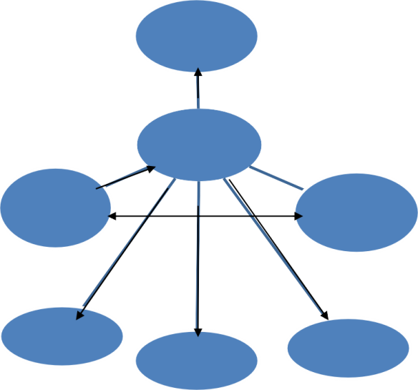

Mgmt Me

Counsellin Committee SW

Aims and Objectives

•   To bridge the gap between the mentor and the mentee.  
•   To ensure the quality performance of the students in academics.  
•   To deal with the related issues for the holistic development of the students.  
•   To provide mutual support and congenial learning environment.  
•   To inspire and motivate for higher studies and competitive examinations.  
•   To discuss stress related issues.  
•   To regulate the academic involvement and assess the outcome.

**Programme Details**

• Mentees shall be assigned to the mentors right from the first year of the programme.  
•   A mentor shall not have more than 20 or less mentees at a time.  
•   The mentees preferably be attached to the same mentor for the entire duration of the programme.  
•   The mentor shall meet the mentees regularly and record the outcome of the meeting in the hard copy. The details about each mentee will be recorded and periodically updated.  
•   The mentor shall identify the students performing exceptionally well in curricular or co-curricular activities by contacting the respective departments under consideration and report to the head of the institution/department for providing further motivation to advanced/gifted learners.  
•   The mentor shall also identify the students whose performance/attendance is below par. The mentor shall interact with the student and try to find out the cause of the problem or an indifferent behavior. If required the mentor will involve the parents, head of the department for reforming the student.  
a. Academic Matters: The mentor shall also keep a track of the academic performance of mentees including continuous assessment, term and examination and help the mentee through counselling or by arranging remedial teaching, if necessary  
b. Behavioural and discipline matters  
c.   Health and physical well being  
d.   Achievements, talents and co-curricular activities  
e.   Stress related issues

**Duties/Responsibilities of Mentor**

a. Introduce and discuss the concept of mentor- mentee system with the assigned mentees.  
b.   Call a meeting of all mentees and record their necessary details in the designated form, note any specific requirement of a students and discuss with them the complete schedule of future meetings  
c.   Keep a track of the attendance, academic performance and behavioural aspects of the students by interacting with exam department and the hostel authorities etc.  
d.   Support students academically and emotionally  
e.   Contact parents to inform the progress of their ward, whenever required and visit the houses of mentees at least twice in the year.  
f.   Maintain a record of the progress made by the identified underperforming students and take remedial actions wherever required.  
g.   To guide students and also to arrange for remedial teaching if required

**Duties/Responsibilities of Mentee**

a. Attend meeting regularly  
b. Fill personal information in the form at the time of joining the mentor- mentee system.  
c. Provide details of attendance, continuous assessment, term end examination, co-curricular, extra- curricular activities to the mentor whenever asked for.  
d. Repose confidence in the mentor and seek his/her advice whenever required.

## Parameters for Mentee Assessment

Assessment by Mentors is a continually evolving process. It should be engaging and student- centric. Assessment rather than evaluation, supports student initiatives to help themselves in improving their performance. It focuses on certain criteria for grading the mentee. The Mentee-

1. Is **Punctual**
2. Undertakes **responsibilities**-Spokesperson/Leader/Peer Mentor or any other
3. Engages in **Quality Voluntary Interaction**, **frequently**
4. Undertakes Supportive/Positive/ **Roles**
5. Employs **Personal Development Strategies**-Seeks suggestions/is cordial in taking advice/is prompt in following instructions/ applies given inputs for personal improvement/ is meticulous in providing feedback
6. Develops **Team Spirit**& Team building initiatives
7. Cultivates **commitment**/remains **accountable** for his or her omissions & commissions
8. Has **creative** impulses & exhibits them in extra/co-curricular activities
9. Demonstrates healthy **Interpersonal Skills**
10. **Promptly furnishes** all the required **data**

**Note:** All the above criteria are graded equally. Each criterion is ascribed a value of 1 and the scores are calculated on a scale of 1 to 10.

## GRADING KEY

|  |  |  |
| --- | --- | --- |
| **Performance** | **Grade** | **Scores** |
| Extraordinary | **A** | **7 and above** |
| Good | **B** | **5& Below 7** |
| Satisfactory | **C** | **Up to 4** |

The Mentor-Mentee interaction provides an opportunity to document the journey of a learner’s life. It is a portal for the mentee to carry his/her progress into the larger world space. Therefore, kindly generate with care and precision, the Certificate, as the mentees produce the Mentor Certificate for career mobility and advanced studies.