N.V.Society’s
N. V. Arts, Sri Kanhyalal Malu Science &
Dr. Pandurangrao Patki College of Commerce,
Kalaburagi

Internal Quality Assurance Cell (IQAC)

PROCESS MANUAL FOR SLOW LEARNERS
&
ADVNCED LERNERS (IDENTIFICATION & ACTIVITIES)

Date | 01/07/2019

N.V.Society’s
N. V. Arts, Sri Kanhyalal Malu Science &
Dr. Pandurangrao Patki College of Commerce,
Kalaburagi

Internal Quality Assurance Cell (IQAC) Process Manual for
Slow Learners and Advanced Learners
(Identification & Activities)

Introduction:
Within the classrooms faculty have to deal with different types of students; some are very intelligent who learn very fast and some are quite weak who learn very slowly. Therefore it is required to determine the abilities of the students in the class. Based on the ability determined, some students need only guidance and some students need a hard work and regular attention.

On the basis of their preceding exam performance, current subject performance and class observation, learning speed students can be classified in two groups; advanced learners and slow learners. Each type of students has different learning attitudes and learning habits. A faculty has to adapt a teaching methodology such that he/she may not lose the attention of the slow learners and turn off the advanced learners.
The purpose of assessment of the learning levels of the students and conduction of activities for them is
- Identification of the slow learners and advanced learners in the class
- To ensure that slow learners and advanced learners are taken care as per their needs
- To help them out for improvement in their academics.
The remainder of this manual describes the constituent parts of the slow learner and advanced learner identification process and activates for them and includes guidance on process.

Process Input:
To start identification of slow and advanced learner process following inputs is needed
  - Preceding examination overall result
  - Class test result
  - Class observation by subject teacher

Process of Slow learners and Advanced Learners (Identification and Activities):
The process of assessment of the learning levels of the students and conduction of activities for them should be carried out through a systematic procedure as shown in the flow chart and explained in detail as below:

Class Test Conduction
Class Test Evaluation
Prepare Class Test Result Report

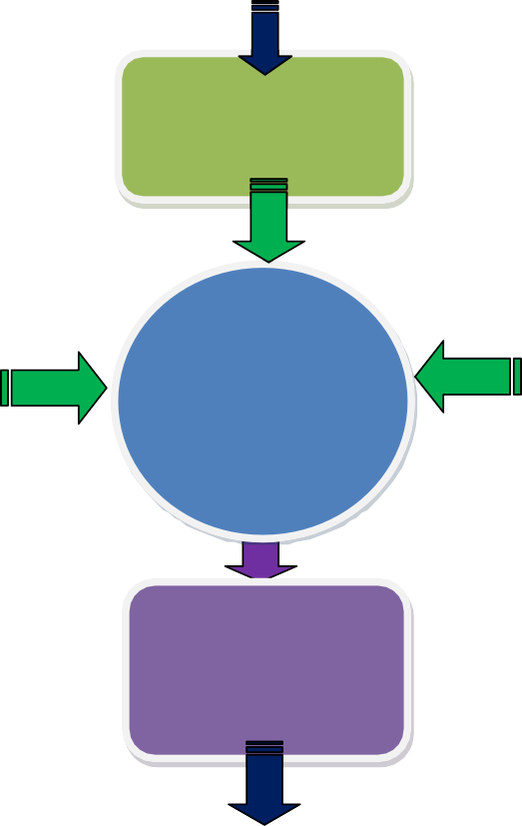Class Test Result (Weightage 50 %)

Preceding University Examination Overall Result (Weightage 25 %)

Assessment of the learning levels of Students
Class Observation of Subject Teacher on the Scale of 1 to 10
(Weightage 25%)

Report Based on Assessment Parameter for Entire Class

IF Total Assessment % is Less Than or Equal To 40 %

Check Total Assessment
%

IF Total Assessment % is Greater Than or Equal To 70 %

Slow Learner
Advanced Learner

Conduct Activities for Both Learners

Prepare Performance improvement Report Process of Slow Learner and Advanced Lerner

- Assessment of the learning levels of the students:
  - Slow learner and advanced learners would be identified for each subject
separately by respective subject teacher for all the semesters.
  - Process to identify of slow learners and advanced learners would be conducted immediately after declaration of preceding semester university exam result or after one month of teaching in case of FE (SEM I).
  - Every subject teacher should conduct class test / online objective type test of their subject on syllabus covered till date or on first unit of 20 marks and duration of one hour to identify slow learners and advanced learners
  - Slow and advanced learners are identified based on following parameters and their weightage.

Sr.  No. | Parameter | Weightage in  Percentage
1 | Marks obtained by student in objective type test /class test / unit test conducted for respective subject | 50%
2 | Academic performance of students in preceding university examination | 25%
3 | Subject teacher observation | 25%

  - For parameter no. 3 every subject teacher should assess each student on scale of 1 to 10.
- Based on above parameter a report would be prepared for whole class for total 100%.
- The student securing marks below 40% would be identified as Slow Learners and the student securing marks above 70 % would be identified as Advanced Learners.
- After that separate list are prepared for both type of learners for further monitoring and conduction of problem solving sessions /revision sessions for them.

Conduction of activities for Slow learners:
  - Provisions should be made in weekly time table by adding extra one hour to conduct problem solving sessions /revision sessions/extra sessions
  - Personal Attention should be provided by respective subject teacher in teaching
  - Assignments and solving University question papers
  - Question bank
  - Counselling – special hints and techniques

Conduction of activities for Advanced learners
  - Advanced assignments or tasks should be assigned to advanced learners
  - Encouragement to complete Advanced courses if any
  - Encouragement Participation in Seminars/Conferences/Technical Events
  - Assignment based on Model making/building
  - Industrial visits and industry sponsored internships
  - Platform should be provided through MoU’s with various reputed Industries/ Research institute for the advanced learners to explore their talents.

Weekly One Hour Extra Session
Counselling
– special hints and techniques
Make up Classes and Extra Practical Sessions
University Question Paper Solving
Slow Learner
Personal Attention
Assignment Solving
Activates Conducted for Slow Learner
Advanced Courses
Advanced Assignments or Tasks
Seminars / Conferences / Technical Events

Adv. Learner

Platform Through MoU’s with Industries

Model Making / Building
Industry Sponsored Internships
Activates Conducted for Adv. Learner

- Preparation of Performance improvement report of slow learner
  - Each faculty should prepare report after university result declaration of current semester which shows the improvement in performance of slow learners to close the loop.

Roles and Responsibilities of Subject Teacher:
Subject Teacher is responsible for carrying out different aspects of slow leaner and advanced learner identification and activities to be conducted
Subject Teachers will be responsible for:
- Conducting class test on unit 1 of 20 marks and duration of one hour.
- Evaluation of class test answer sheets and preparing the class test result report of class
- Preparing and maintaining report for whole class based on parameter decided for
assessment of the learning levels of the students with their weightage
- Preparing separate list of slow and advanced learners
- Preparing schedule for extra sessions /problem solving sessions / revision sessions for slow learners.
- Conducting the sessions for slow learners as per prepared schedule.
- Maintaining the attendance of slow learners sessions.
- Preparing the list of advanced assignment or list of tasks assigned to advanced learners.
- Preparing the report after university result declaration of current semester which shows
the improvement in performance of slow learners to close the loop.
- Maintain the all records for slow learners and advanced learners activity

Documents to be maintained
- Cover page for Slow & Adv. learners Activity
- Report of result of class test / unit test
- Report of marks obtained based on above parameter
- List of slow learners
- List of Advanced Learners
- Schedule of activity for slow learners
- Attendance record for session conducted for slow learners
- Report of performance improvement for slow learners
- List / Record of tasks given to advanced learners

Expected Outcome
  - Timely conduction of slow learners activities
  - Records based on student progress and observation.
  - Improvement in University Result.

